

Pegasys Reports Portal

Pegasys 6.5 User Guide

General Services Administration

Contract # GS-35F-4797H
Delivery Order # GS-V00-09-PD0220

Final

March 13, 2012

Table of Contents
Table of Contents i
Revision Log i
1. Introduction 1-1
1.1 Pegasys Reports Portal 1-1
2. Report Execution 2-2
2.1 How to Access the Pegasys Reports Portal 2-2
2.2 How to Run a Report 2-4
2.3 How to View Report Output and Parameters 2-6
2.4 How to Delete Report Output 2-9
2.5 How to Add a Shortcut to Report Output 2-9
3. Scheduled Reports 3-11
4. Report Subscription 4-12
4.1 How to Subscribe to a Report 4-12
4.2 How to Manage Report Subscriptions 4-13
5. Report Security 5-1
5.1 Security Organization 5-1
Appendix A – Pegasys Report Portal Directory Structure 5-1
Appendix B – Additional Resources for New Users 5-1
Appendix C – Pegasys Access Form Instructions 5-2

Revision Log

Date | Version | Description | Author | Reviewer | Review Date
1/2012 | Draft/Version .1 | Original Draft | Daniel McNeil
3/2012 | Final | Original Final | Daniel McNeil
3/2012 | Version 2 | Revised Final | Daniel McNeil

Introduction

Pegasys Reports Portal
The Pegasys Reports Portal provides a single entry point for all reports functionality within Pegasys, which allows for a streamlined and intuitive user experience.
Report users can access both reports run within Pegasys and reports that have been executed outside of Pegasys and imported into Pegasys, previously available through Pegasys Online!
Pegasys Reports Portal also enables efficient distribution of report outputs. Rather than having each user create a report execution, a shared instance can be viewed by many users; this is particularly useful for large reports that are run on a regular basis, such as month-end reports.
Additionally, the Pegasys Reports Portal provides users with the ability to "subscribe" to reports. A user can subscribe to a report to receive email notification any time the report is run.

Report Execution

How to Access the Pegasys Reports Portal
Pegasys users who only have access to the Pegasys Reports Portal will see a simpler version of the desktop and are brought directly to the View Reports page upon logging into Pegasys.

Desktop for Pegasys Reports Portal Only Users
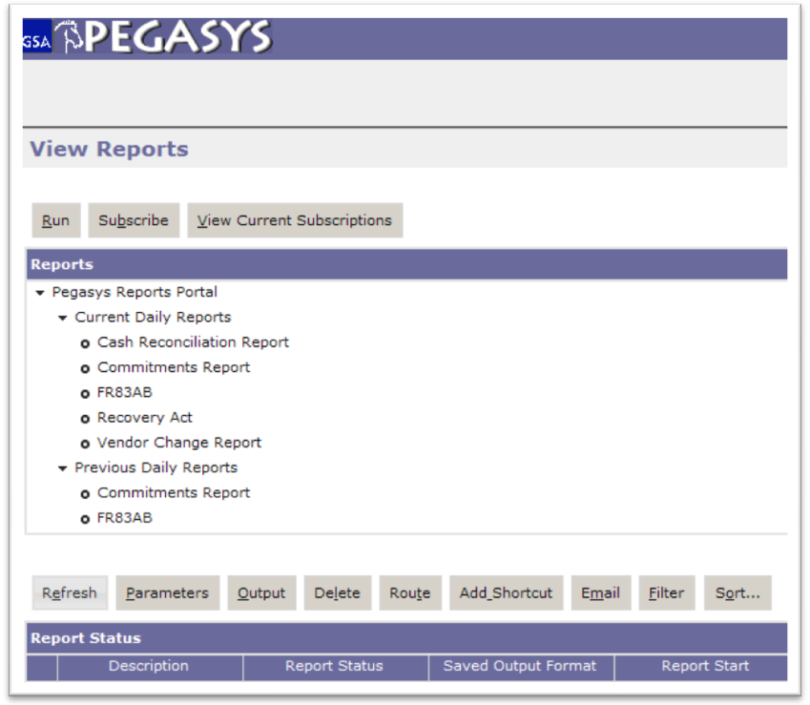
See Appendix C – Pegasys Access Form Instructions for information on how to request access to Pegasys.

Pegasys users with access to the Pegasys Reports Portal and additional subsystems will see the customary desktop. For these users, reports are accessed from the Utilities menu.

Standard Desktop for Existing Pegasys Users
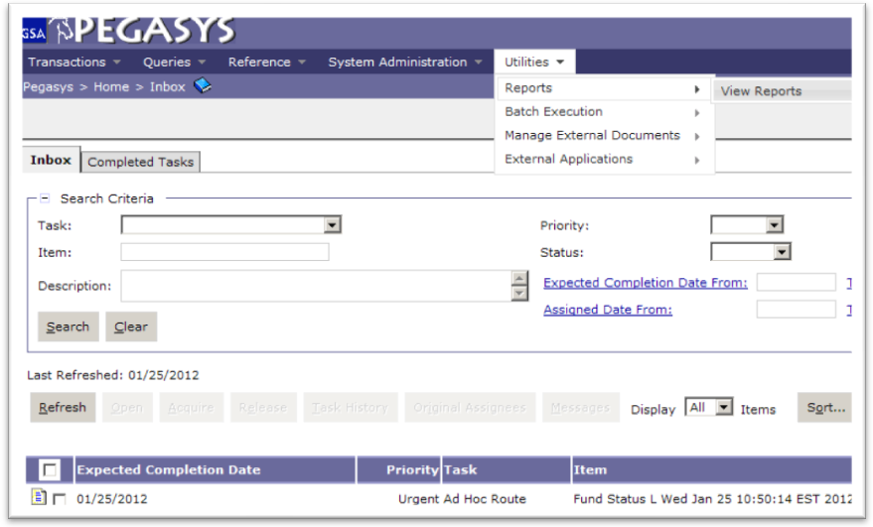

How to Run a Report
The following steps describe how to run a report in Pegasys. They are applicable to On Demand reports as well as subsystem specific reports.
Note: Daily reports, month end reports, Recovery Act reports, etc. are generated outside of Pegasys. The output from these reports is imported into the Pegasys Reports Portal. See Section 2.3 for information on viewing report output.
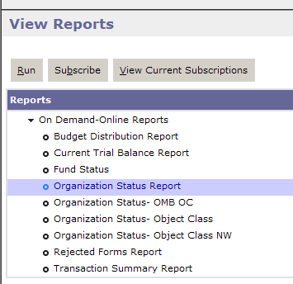

- Navigate to the View Reports page.
- Expand the appropriate folder and subfolder.
The Pegasys Reports Portal folder contains the reports previously available through Pegasys Online!
See Appendix A – Pegasys Report Portal Directory Structure for a list of all folders and reports.
- Select the desired report.
- Click the Run button.
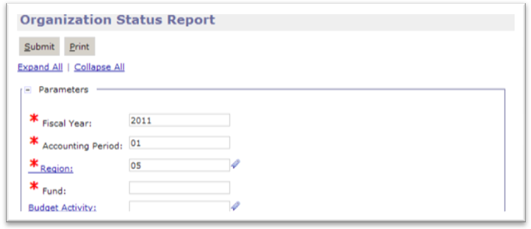
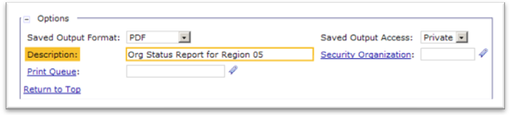
- Enter parameters and options as needed.
- The Saved Format Output option defaults to PDF. Select HTML or CSV to specify a different format if desired.
- The Saved Output Access option defaults to Private. Select Shared if the report output is to be viewed by other Pegasys users.
- The Security Organization is required for shared reports. Specifying a security organization of GSA makes the report available to all report users. Otherwise specify a more specific security organization to restrict access to the report output. Private reports do not require a security organization.
- Optionally the Description field may be used to add text to help identify the report output.
- Click the Submit button or Run button depending upon the selected report. A message indicates the report was successfully submitted.
- Click the Close Window link.
- Click the Refresh button. Information about the report output is displayed in the Report Status section. Initially the status will be Pending. It will change to Complete once the report is finished.

How to View Report Output and Parameters
The following steps describe how to view report output in Pegasys. They are applicable to subsystem specific reports, On Demand reports, and scheduled reports.
Note: Daily reports, month end reports, Recovery Act reports, etc. are generated outside of Pegasys. The output from these reports is imported into the Pegasys Reports Portal. The latest output of the report is found in the Current folder; all prior outputs are found in the Previous folder.

- Navigate to the View Reports page.
- Expand the appropriate folder and subfolder.
The Pegasys Reports Portal folder contains the reports previously available through Pegasys Online!
See Appendix B for the Reports Portal Directory Structure
- Select the desired report.
- Click the Refresh button. Information about the report output is displayed in the Report Status section.
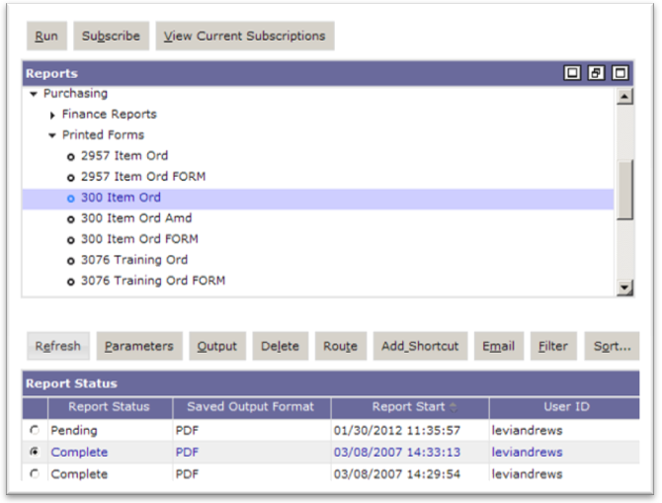
- If there are many instances of the report output, use the following display features.
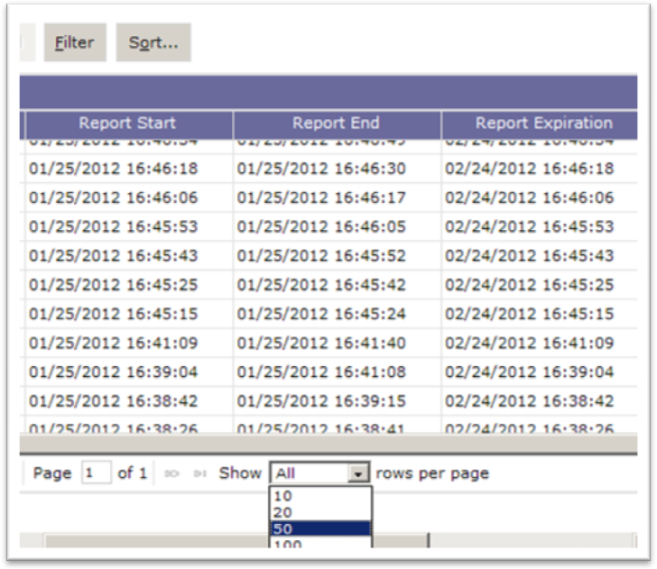
Typically Pegasys defaults to display 10 records at a time. Use the drop down box in the lower portion to show additional rows of report output. In addition, the minimize list button, restore list button, and maximize list button control if the rows are displayed in one large area or in a smaller window with scroll bars.
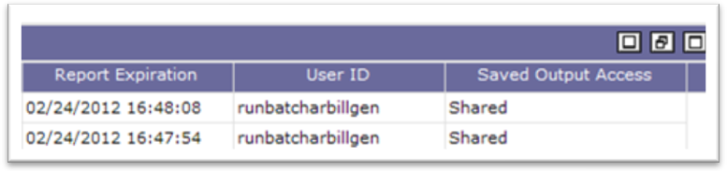
- The sort or filter features also provide convenient ways to find a particular report instance.
- It is possible to sort the report instances by clicking on any column heading. For example, clicking the Report Start heading will arrange the output from newest to oldest. Clicking again will sort in the opposite order.
- Click the Sort button for the ability to sort on one or more column headings. For example, use the Sort by window to arrange the instances of output by Report Start in descending order and then by Description in ascending order.
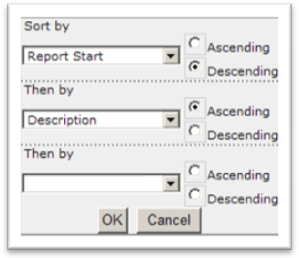
- Click the Filter button for the ability to display only those instances that meet certain conditions. For example, enter a From Start Date and a To Start Date to select output from a particular time interval.
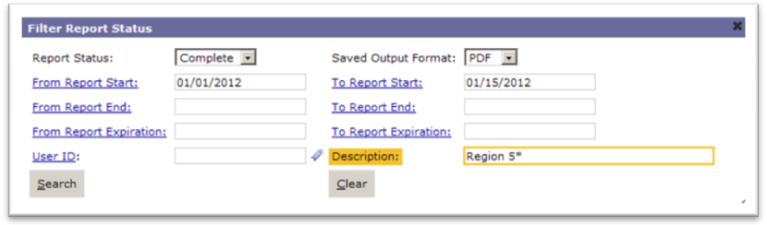
Note. Using an asterisk (*) in the Description allows the user to filter on a portion of the text in the field. In this case, only reports that began with a description of Region 5 which completed and were executed between 1/1/2012 and 1/15/2012 would be listed.
- Click the radio button to highlight an instance of the report. This enables additional buttons.
- Click the Parameters button to display the values used to generate the report in the Parameters window.
- Click the OK button to return to the View Reports page.
- Click the Output button to display the results of the report in its own window.
- Use the arrow button to scroll through the pages of the report.
- Use the x button at the top of the report window to close the report output.

How to Delete Report Output
Report output may be deleted only by the user who ran the report.
- Follow the steps in 2.3 to select a particular instance of a report.
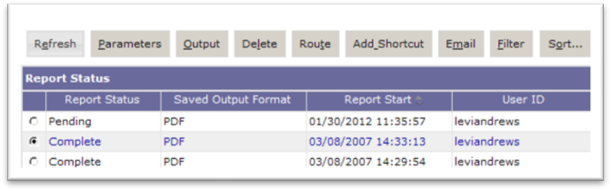
- Click the Delete button.
- Click Delete in the Report Status Delete Confirmation window.

How to Add a Shortcut to Report Output
A shortcut may be created to a particular report instance as a convenient way to return to the output from the Shortcuts menu.
- Follow the steps in 2.3 to select a particular instance of a report.
- Click the Add Shortcut button.
- A message indicates the action was successful.
- Click the Shortcuts link in the upper right corner.
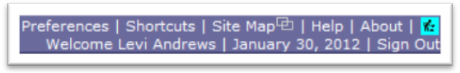
- The Shortcuts page displays an icon and a link to the report output.
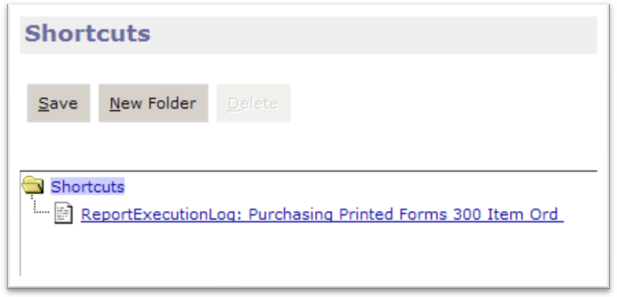
- Click the report link to display the report output.
- Use the x button at the top of the report window to close the report output.

Scheduled Reports
Many reports are automatically scheduled on a daily, weekly, monthly, quarterly, or annual basis. These scheduled reports are imported into the Pegasys Reports Portal and made available to Pegasys Report users.
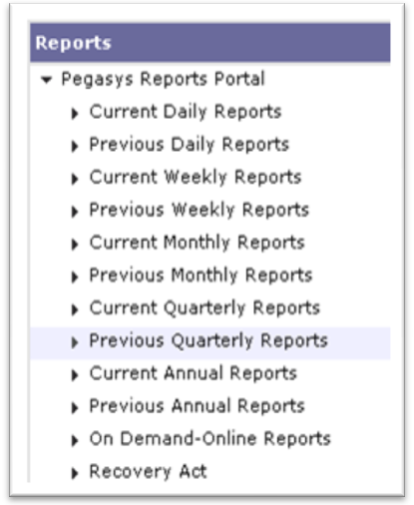
The most recent instances of the schedule report are found in its corresponding Current folder. One instance is the PDF version and the other is the CSV version. The CSV version is useful for working with the report data in a format compatible with Excel. Each time new reports are generated, the items in the Current folder are moved to the corresponding Previous folder, and the new instances appear in the Current folder.

Occasionally it is necessary to re-run a scheduled report, especially if the report did not generate properly in the first place. In this case, the item is the Current folder is deleted rather than moved to the Previous folder and the new instance of the report appears in the Current folder.

Report Subscription
The Pegasys Reports Portal provides the ability to subscribe to a report in order to receive an automatic email notification every time a specified report is run.
Careful consideration must be taken when subscribing to a scheduled report. Many scheduled reports generate multiple report outputs. For example, the Fund Status report generates over a hundred output files. A report user who subscribed to the Fund Status report would receive over a hundred emails each month.

How to Subscribe to a Report
Report output may be emailed to the inbox of the email application of a Pegasys user.
- Navigate to the View Reports page.
- Select a specific report.
- Click the Subscribe button.
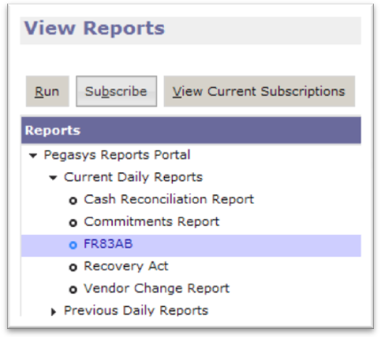
- Enter the User ID to receive email notifications when the particular user runs the shared report or leave the User ID blank to receive email notifications whenever the shared report is run.
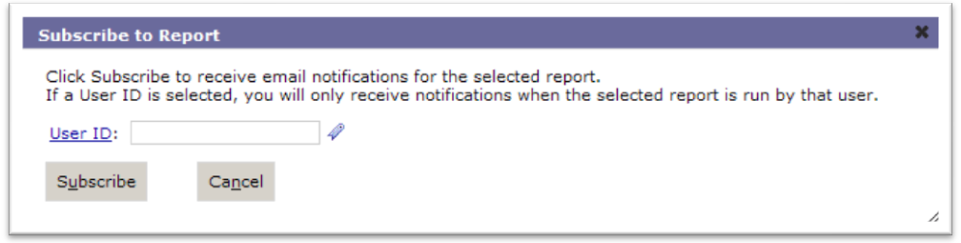
- Click the Subscribe button.
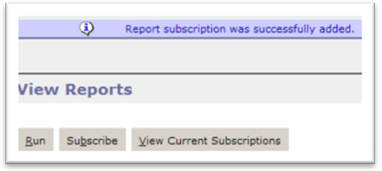

How to Manage Report Subscriptions
The Current Subscriptions window allows a user to view existing subscriptions as well as delete subscriptions.
- Navigate to the View Reports page.
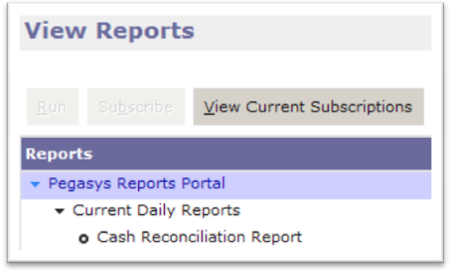
- Click the View Current Subscriptions button.
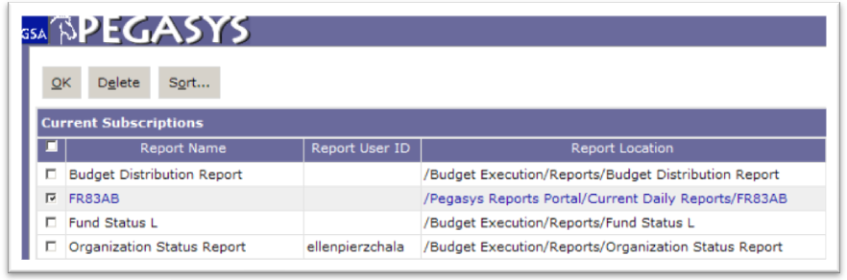
- Select a subscription to Delete if email notifications are no longer needed
.
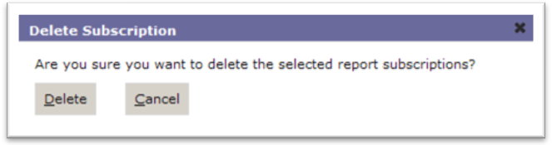
- Click the Delete button to confirm.
- Click OK button to return to the View Reports page.

Report Security
Security is used in the Pegasys application to ensure users are only provided access to the reference data, transaction, queries, and reports required by their job description. Particular to the reports application, security can be used to ensure a system administrator has the capability to limit the reports users can access. Users can also limit the users that can access report outputs they generate in “Shared” status by identifying a security organization.

Security Organization
Every Pegasys user is assigned to at least one security organization. Security organizations are hierarchical. Here is a small sample of the many security organizations at GSA.
GSA

GMA

BB
BC
BD

Suppose one report user belongs to security organization BC and another belongs to security organization BD. If the first user shares a report and assigns it to security organization BD, then only Pegasys users who belong to BD will receive email notifications if they subscribed to the report and see the particular instance of the first user’s output listed among all of the outputs when selecting the report. In this case, the second reports user would not have access to the report. If the first user assigned the report to a security organization at a higher level, then more Pegasys users would have access to the report. For example, if the user specified GMA as the security organization, than users with BB, BC and BD security organizations would be able to see the report output.
Be aware that assigning a shared report to the security organization GSA makes it available to every GSA user, but it also means all users subscribed to the report will receive email notification and every report user within GSA will see it listed among the outputs displayed for the report.

Appendix A – Pegasys Report Portal Directory Structure
The following bullets display the folder structure in the tree-like structure that the user will view within the Reports Portal.
Pegasys Reports Portal
Business Rules
- Deferred
- Obligation Status
Current Daily Reports. The following reports that will be included in this report folder are:
- Cash Reconciliation Report
- Commitments Report
- FR83AB
- Vendor Change Report
Previous Daily Reports
- Cash Reconciliation Report
- Commitments Report
- FR83AB
- Vendor Change Report
Current Weekly Reports
- BC 1265 Aged Billed Receivables
- Header to Line System Assurance
Previous Weekly Reports
- BC 1265 Aged Billed Receivables
- Header to Line System Assurance
Current Monthly Reports
- 472E
- 70P1
- 70P2
- Accelerated Payment Metrics
- Aged Deferred (OMB)
- BC1008 AR Subsidiary Ledger
- BC1033 Disputes
- BC1040 Aged Unbilled Receivables
- BC1046 Billed Receivables Summary
- BC1048 Outstanding Chargebacks
- BC1049 Federal vs. NonFederal Billings
- BC1050 Top 10 Federal Delinquencies
- BC1055 Federal vs. NonFederal Write-Off
- BC1056 Cash Collection Summary
- BC1067 Unsummarized DBE Detail
- BC1067 Unsummarized DBE Detail Orphan
- BC1080 DBE Billings Summary
- BC1095 Detailed Billed
- BC1189 Unapplied Collections
- BC1190 Credit Application
- BC1265 Aged Billed Receivables
- BC1283 Sales to Agency
- BC1300 Customer Generated Exception
- BCF030 Billed Rent AR Subsidiary Ledger
- Commitments Report
- Consolidated Trial Balance
- Deferred
- Deferred Aging Report
- Discount Reports
- FA816 DC Courts
- FA816 GSA
- FA816 TAS
- FA Inventory Status DC Courts
- FA Inventory Status GSA
- FA TB Recon DC Courts
- FA Trial Balance Reconciliation - Depreciation
- FA TB Recon GSA
- FR498
- FR83AB
- FTE
- Fund Status
- Header to Line System Assurance
- Interest Reports
- IT Fund
- Obligation Status
- Organization Status
- PBS Disbursements
- Purged Forms
- TAR Reports
- Trading Partner Type Trial Balance Reports
- Trial Balance Reports
Previous Monthly Reports
- 472E
- 70P1
- 70P2
- Accelerated Payment Metrics
- Aged Deferred (OMB)
- BC1008 AR Subsidiary Ledger
- BC1033 Disputes
- BC1040 Aged Unbilled Receivables
- BC1046 Billed Receivables Summary
- BC1048 Outstanding Chargebacks
- BC1049 Federal vs. NonFederal Billings
- BC1050 Top 10 Federal Delinquencies
- BC1055 Federal vs. NonFederal Write-Off
- BC1056 Cash Collection Summary
- BC1067 Unsummarized DBE Detail
- BC1067 Unsummarized DBE Detail Orphan
- BC1080 DBE Billings Summary
- BC1095 Detailed Billed
- BC1189 Unapplied Collections
- BC1190 Credit Application
- BC1265 Aged Billed Receivables
- BC1283 Sales to Agency
- BC1300 Customer Generated Exception
- BCF030 Billed Rent AR Subsidiary Ledger
- Commitments Report
- Consolidated Trial Balance
- Deferred
- Deferred Aging Report
- Discount Reports
- FA816 DC Courts
- FA816 GSA
- FA816 TAS
- FA Inventory Status DC Courts
- FA Inventory Status GSA
- FA TB Recon DC Courts
- FA Trial Balance Reconciliation - Depreciation
- FA TB Recon GSA
- FR498
- FR83AB
- FTE
- Fund Status
- Header to Line System Assurance
- Interest Reports
- IT Fund
- Obligation Status
- Organization Status
- PBS Disbursements
- Purged Forms
- TAR Reports
- Trading Partner Type Trial Balance Reports
- Trial Balance Reports
Current Quarterly Reports
- BC1046 Billed Receivables Summary
- BC1049 Federal vs. Non-Federal Billings
- BC1055 Federal vs. Non-Federal Write-Off
- BC1080 DBE Billings Summary
- BC1283 Sales to Agency
Previous Quarterly Reports
- BC1046 Billed Receivables Summary
- BC1049 Federal vs. Non-Federal Billings
- BC1055 Federal vs. Non-Federal Write-Off
- BC1080 DBE Billings Summary
- BC1283 Sales to Agency
Current Annual Reports
- BC1046 Billed Receivables Summary
- BC1049 Federal vs. Non-Federal Billings
- BC1055 Federal vs. Non-Federal Write-off
- BC1056 Cash Collection Summary
- BC1080 DBE Billings Agency
- BC1283 Sales to Agency
Previous Annual Reports
- BC1046 Billed Receivables Summary
- BC1049 Federal vs. Non-Federal Billings
- BC1055 Federal vs. Non-Federal Write-off
- BC1056 Cash Collection Summary
- BC1080 DBE Billings Agency
- BC1283 Sales to Agency
On Demand/ Online Reports
- Budget Distribution Report
- Current Trial Balance Report
- Fund Status
- Organization Status- Object Class
- Organization Status- Object Class NW
- Organization Status- OMB OC
- Organization Status Report
- Rejected Forms Report
Recovery Act
Current Daily Recovery Act Reports
- 83ab – 442
- Fund Status ARRA
Previous Daily Recovery Act Reports
- 83ab – 442
- Fund Status ARRA
Current Monthly Recovery Act Reports
- 83ab
Previous Monthly Recovery Act Reports
- 83ab
Current Weekly Recovery Act Reports
- Fund Status ARRA
Previous Weekly Recovery Act Reports
- Fund Status ARRA

Appendix B – Additional Resources for New Users
The Pegasys Support page (pegasys.gsa.gov) provides several useful documents for new users.
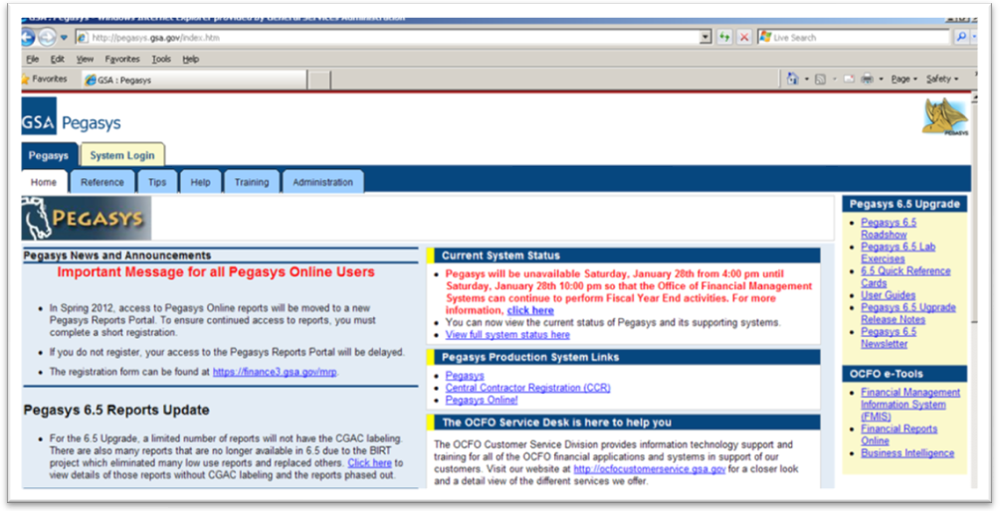
User guides, newsletters, and quick reference cards are available in the Pegasys 6.5 Upgrade section found on the upper right side of the Home tab.
6.5 Quick Reference Card
- Getting Started – provides a basic description of the Pegasys Desktop
Pegasys 6.5 Newsletter
- April 2011 – provides information on Pegasys passwords and Security Questions
User Guides
- Purchasing User Guide or Finance User Guide
Chapter 2 of both of these guides covers the following topics:
2.1 What is Pegasys?
2.1.1 How do I access Pegasys?
2.1.2 How do I obtain a Pegasys user ID?
2.1.3 How do I obtain a Pegasys password?
2.1.4 When does my temporary password expire?
2.1.5 What do I do when I forget my Password?
2.1.6 How do I Sign In to Pegasys?
2.1.7 How do I exit/Sign Out of Pegasys?
2.1.8 How do I change my Pegasys Password?

Appendix C – Pegasys Access Form Instructions
Click on the following link for the Pegasys NEAR Access Request Form. This link may be found on the Pegasys page (pegasys.gsa.gov) in the New Pegasys User Section.
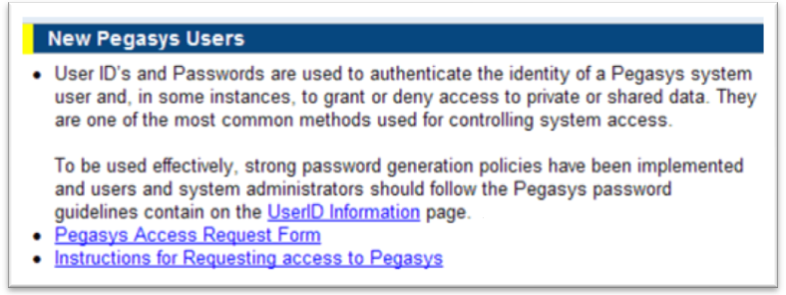
http://support.pegasys.gsa.gov/Ref/Other/Pegasys_NEAR_Access_Request_Form.docx

NOTE: In Section 4, specify the REPORTUSER role in order to access the Pegasys Reports Portal.
Section of the Form | Instructions
- Type of Access Request | - Select Add User, Change Current Roles/Approvals, or Remove User
- Request for Access to OCFO Systems | - Select Pegasys and/or NEAR. The form can be used to request access to both systems. Either section 4 or section 5 must be completed.
- REQUESTOR INFORMATION | - Complete First Name, MI, Last Name. Suffix is optional  - Complete Email Address and Telephone  - Complete Service and Correspondence according to the guidance provided on GSA InSite (http://insite.gsa.gov/portal/content/500188). Note – this information is only required for Pegasys accounts  - Select User Type – GSA Employee, Contractor, or External Client  - Complete Job Title  - Complete Supervising Manager Name, email, and telephone  - Complete User and Supervisor ENT account. ENT account is normally First Name, Middle Initial, Last Name. John Michael Employee’s ENT account would be JohnMEmployee
- PEGASYS ACCESS INFORMATION | - Identify your requested role and approval type. Refer to http://pegasys.gsa.gov/admin/queries.htm  for a list of roles and the conflicting roles matrix for a description of conflicts
- NEAR ACCESS INFORMATION | - Select one NEAR access role  - Enter your NEAR User ID if you are an existing NEAR user who is adding another role to your account
- Requestor | - Click on the “View Signatures” box at the top of the screen. This is on the upper left part of the screen, outside of the form  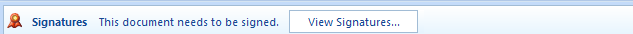  - Right click on Signer1 on the Right Side of the screen (Note: You must be using a SmartCard to proceed)  - Click on Sign  - A dialog box will open up for the digital signature. There will be an X displayed for the user to sign the form  - Type your name and click sign  - The first time you enter your signature, you may be prompted to enter your SmartCard PIN number  - You will see the following confirmation when the signature is completed. You will also see your name and date displayed in the signature block of the form  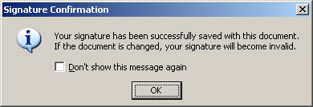
- Supervising Manager | For Users Requesting Access: Leave this section blank. Save the signed form and send as an email attachment to your Supervising Manager  For Supervising Manager: Follow the steps in section 6 to digitally sign the form
- Functional Coordinator /Service Rep Review | For Users Requesting Access: Leave this section blank. Save the signed form and send as an email attachment to your Functional Coordinator/Service Rep  For Functional Coordinator: Follow the steps in section 6 to digitally sign the form

